Holy Week
God’s Sacrificial Love and Invitation to Eternal Life
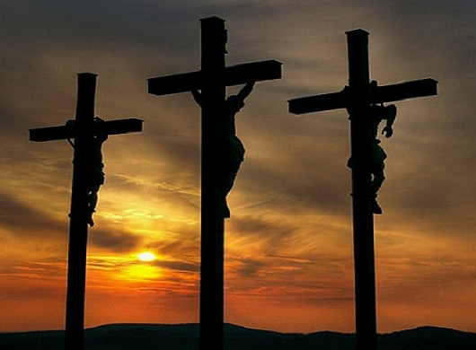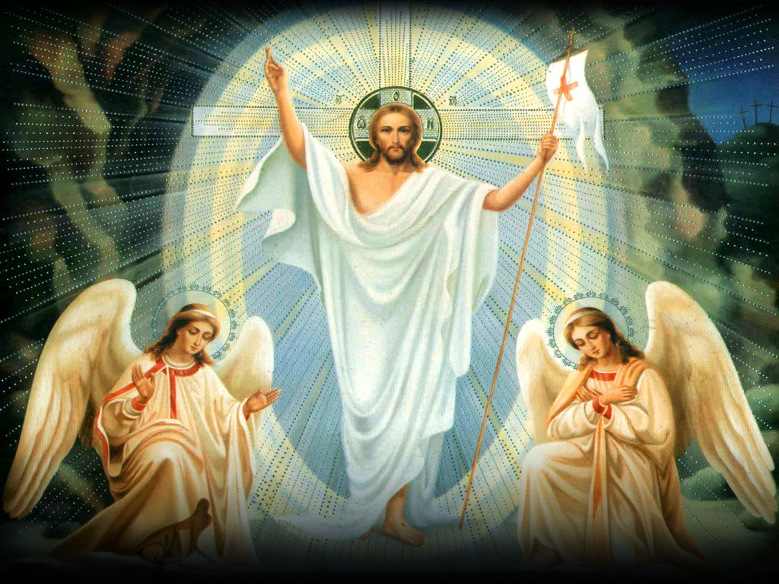
Dear Parishioners,
As we respond to God’s call to love and enter into Holy Week, please take advantage of the opportunities to go to Confession, and invite others along, especially to our Communal Penance Service on Wednesday, April 5, 7:15-8:30p.m. at Holy Trinity. More than one priest will be helping out. Please review the updated April Calendar for Individual Confession times and Masses/services.
With love we want to respect other religious traditions, but especially our own. Let us adore Jesus Christ in the Holy Eucharist. Catechism of the Catholic Church: paragraph 1415 reminds us: “Anyone who desires to receive Christ in Eucharistic communion must be in the state of grace. Anyone aware of having sinned mortally must not receive communion without having received absolution in the sacrament of penance.” A fuller understanding is found in the back of the worship aid “Word and Song.” Those who can receive are reminded to fast one hour before reception, which includes gum, juice, and coffee, with the exception of water and medicine. Thank you for respecting Our Lord in the Eucharist.
An additional Individual Confession time with Adoration will take place on Divine Mercy Sunday, April 16, at St. Columbkill from 11:45-1:00p.m. By making a valid confession that day, a plenary indulgence will be granted. Anyone who would like to know more about this devotion is invited to take a Divine Mercy Novena pamphlet available near the main entrance of all of our parish churches. The Novena starts on Good Friday.
Another devotional opportunity in our parish at Holy Trinity from April 14-16 will be 40 Hours Devotion. This tradition dates from about the year 1527 in Italy, and consists of approximately forty consecutive hours of Eucharistic Adoration. The period is a remembrance of the speculated forty hours from Jesus’ burial until His resurrection, but also a remembrance of Jesus’ forty days of fasting in the desert. Forty Hours Devotion begins at Holy Trinity at 4:30 p.m., Friday, April 14, and concludes at 10:10 a.m., Sunday, April 16. A sign-up sheet will be emailed. All are encouraged to stop in to adore Jesus in the Blessed Sacrament of Love!
Note that after the Holy Thursday Mass all altars are stripped bare, and all votive candles are extinguished and only relit after the Saturday Easter Vigil which begins at 8:30p.m. at Holy Trinity. Please recall that there is NO 5:30p.m. Mass on Saturday, April 8, only the 8:30p.m. Easter Vigil Mass which will take about 1.5 hours.
Please note the special Easter donation envelope included. Thank you for your generosity!
God bless you and your family, and have a Happy Easter Season.
Fr. Thomas E. McCabe

