Holy Mass Schedule |  |  |  | Readings
Sat. | 5:30pm | HT | Oct 10 | +Ron Bredemus | See Mass Readings Below
Sun. | 8:30am | SM | Oct 11 | Parishioners | Is 25:6-10a; Ps 123:1-6; Phil 4:12-14, 19-20; Mt 22:1-14 or 22:1-10
Sun. | 10:00am | SC | Oct 11 | Bill & Judy O’Reilly Family
Mon. | 8:00am | SM | Oct 12 | +Ron Bredemus | Gal 4:22-24, 26-27, 31-5:1; Ps 113:1b-5a, 6-7; Lk 11:29-32
Tues. | 7:30am | HT | Oct 13 | +Ron Bredemus | Gal 5:1-6; Ps 119:41, 43-45, 47-48; Lk 11:37-41
Wed. | 8:00am | HT | Oct 14 | + Sandy Johnson | Gal 5:18-25; Ps 1:1-4,6; Lk 11:42-46
Thurs. | 9:00am | SC | Oct 15 | Jim and Sonja Johnson Family | Eph 1:1-10; Ps 98:1-6, Lk 11:47-54
Fri. |  |  | Oct 16 |  | Eph 1:11-14; Ps 33:1-2, 4-5, 12-13; Lk 12:1-7
Sat. |  |  | Oct 17 |  | Eph 1:15-23; Ps 8:2-3b, 4-7; Lk 12:8-12
Sat. | 5:30pm | HT | Oct 17 | Parishioners | See Mass Readings Below
Sun. | 8:30am | SM | Oct 18 | + Margaret Wagner | Is 45:1, 4-6, Ps 96:1, 3-5, 7-10; 1 Thes 1:1-5b
Sun. | 10:00am | SC | Oct 18 | Families of our Parish Youth | Is 45:1, 4-6, Ps 96:1, 3-5, 7-10; 1 Thes 1:1-5b
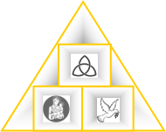
New Mass Times
St. Mary’s Sunday
Mass 8:30am

St. Columbkill
Sunday Mass
10:00am
Fr. Thomas McCabe, Pastor: pastor@holytrinitygoodhue.org
Zachary Siebenler, Faith Form. Assistant/Safe Environment Coordinator: faithformation@holytrinitygoodhue.org
Cathy O’Reilly, Administrative Assistant/Bulletin Editor/Bookkeeper: admin@holytrinitygoodhue.org

Twenty-eighth Sunday in Ordinary Time, Oct. 11, 2026
Holy Trinity Parish
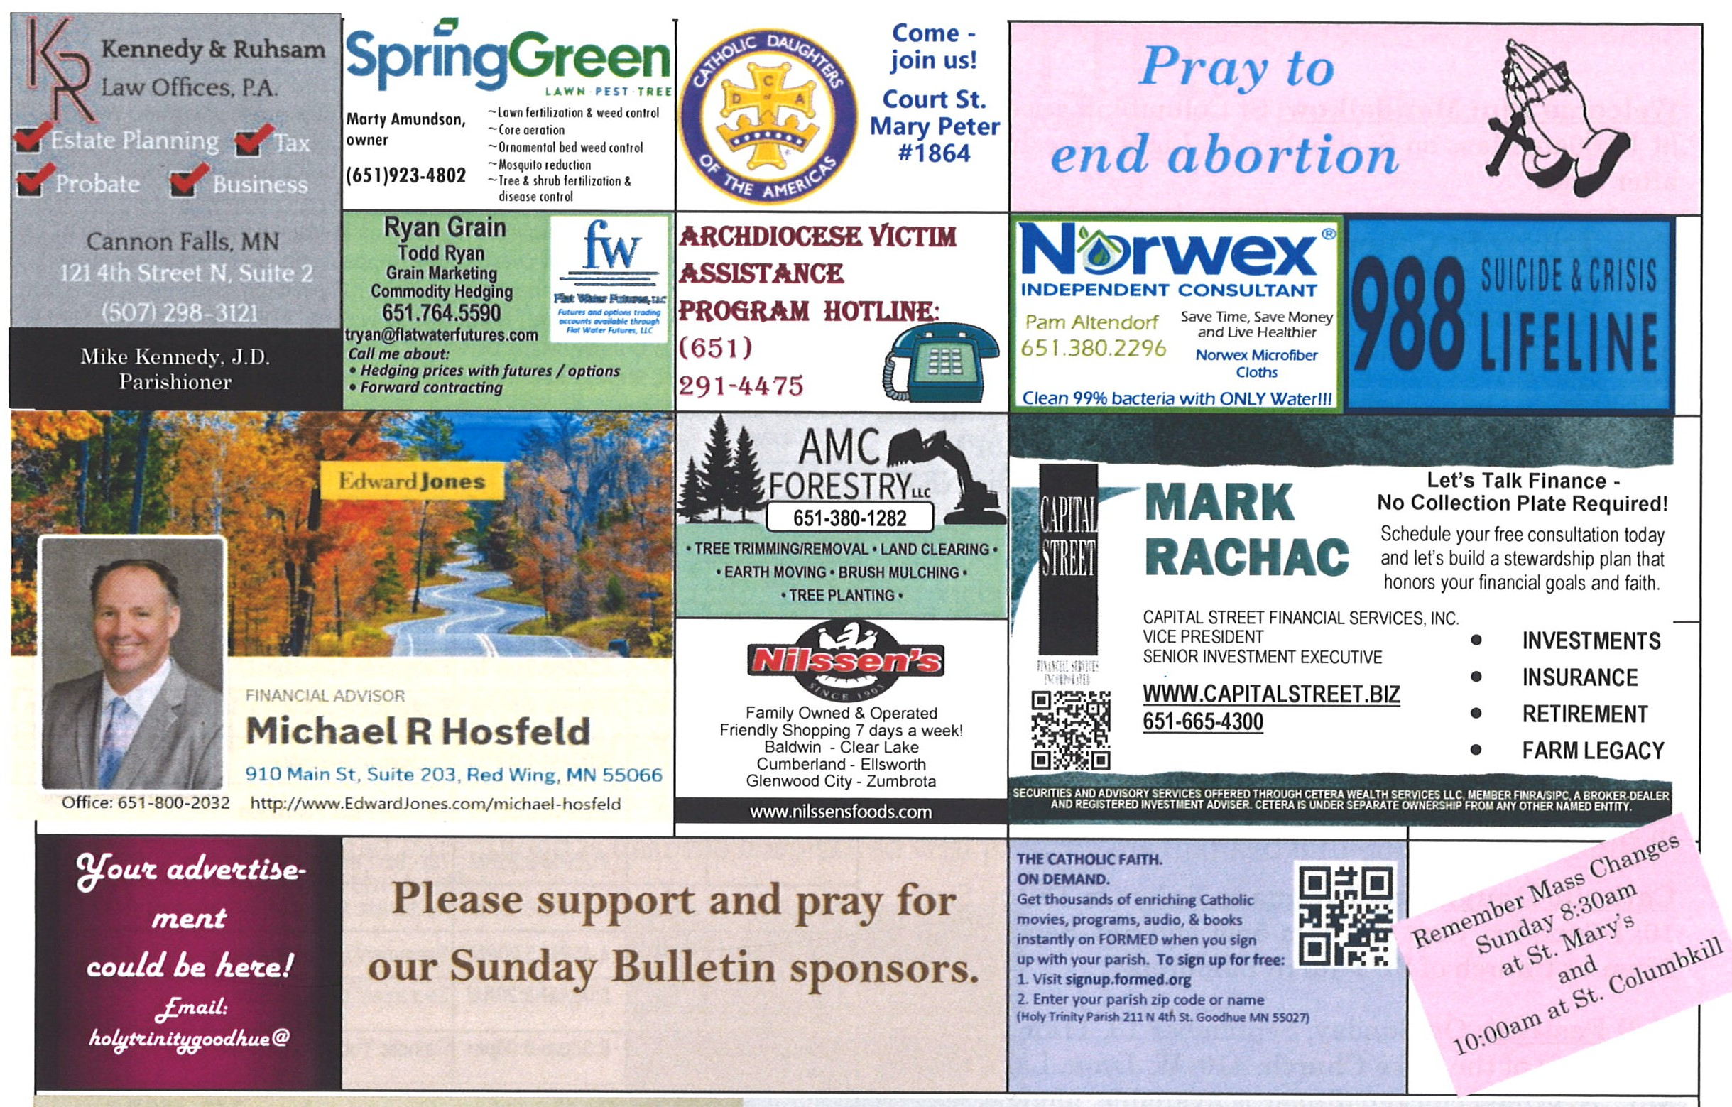
Welcome, Melanie Ann Adams to our family of faith here at Holy Trinity Parish. Melanie Ann is the daughter of Justin and Jennifer Adams. She was baptized on Sunday, September 13th after the 10:00 am Mass at St. Columbkill. Melanie’s older sister is Harper. Praise God for our growing family of faith!
Appalachia ChristMas Mission
Our 3 churches will again be helping with the mission sponsored by the Archdiocese Council of Catholic Women.
A semi-trailer donated by Terminal Transport in Roseville will deliver donated items to 4 parishes in Kentucky. The parish addresses are listed at the back of each church along with a list of suggested new gifts during the month of October. Please donate no later than October 25th. Any monetary donations can be included in the collection basket or sent directly to Holy Trinity Church, just note it is for the Appalachia Mission. Thank you for making someone’s Christmas merrier.

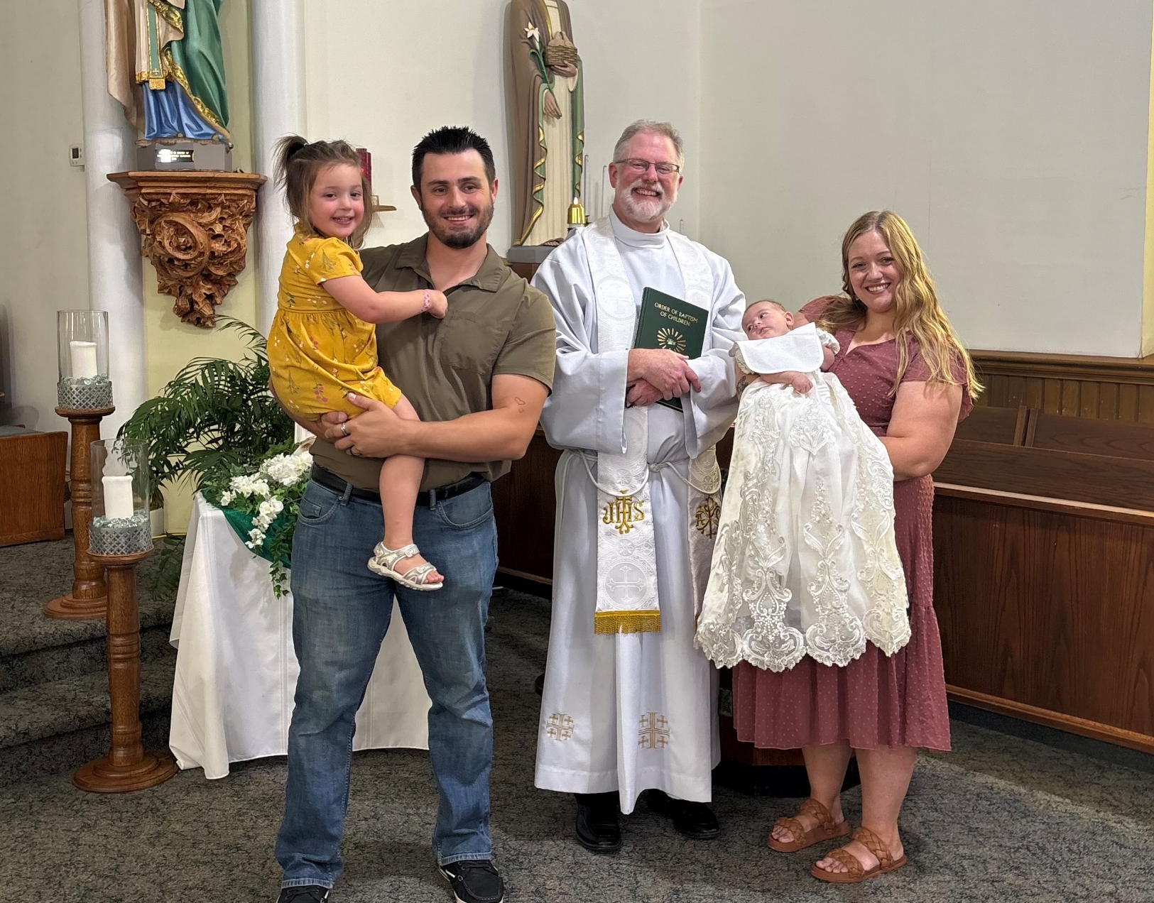

Note New Emails:
Fr, McCabe: pastor@holytrinitygoodhue.org
Zach Siebenaler: faithformation@holytrinitygoodhue.org
Cathy O’Reilly: admin@holytrinitygoodhue.org

Welcome to our Parish Church
Mission: We grow together in Christ.
Address: PO Box 275, Goodhue, MN 55027
Office/Emergency Phone: 651-923-4472
Email: admin@holytrinitygoodhue.org

Website: www.holytrinitygoodhue.org
Office Hours: Generally, Mondays 2:30-5:30pm, unless otherwise noted.

Building Use Request: Call the office
Confession: Sat. 4:45-5:20pm at Holy Trinity; Sun. 8:00-8:20am at St. Mary; Thurs. 8:00-8:45am at St. Columbkill
Baptism: Call at least 3 months before the birth to attend a class and set a tentative date.
First Penance/Eucharist: Register for 1st grade catechism classes in preparation.
Confirmation: Register as soon as possible in the fall since there are requirements including weekly Mass attendance.
Marriage: Please call Father McCabe at least one year prior to tentative date.
Anointing of the Sick: Contact the office especially if serious illness, near death or upcoming major surgery.
Pastoral Care of the Sick: If you move to a nursing home/care facility and would like a priest to visit or are unable to attend Mass and would like Communion at home, contact the office.
Funerals: Contact the office
Mass Intentions: Mail to office or place in collection. ($10/Mass suggested.) Only one name or one couple, and please indicate whether person is living or deceased.
Bulletin Items: Email to admin@holytrinitygoodhue.org by Tuesday noon. The parish office reserves the right to edit.
Trustees:
Samantha Dowden (secretary)
Ed McNamara (treasurer) 651-923-4777
Finance Chair:
Mike Zorn 651-258-4165
Pastoral Council Chair:
Jake Letsinger 763-486-7418

Jesus again in reply spoke; “The kingdom of heaven may be likened to a king who gave a wedding feast for his son. He dispatched his servants to summon the invited guests to the feast, but they refused to come…. Many are invited, but few are chosen.”
MT 22:1-14

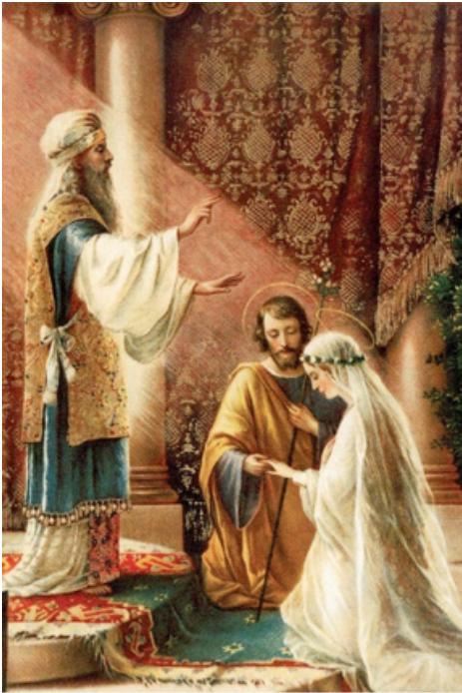
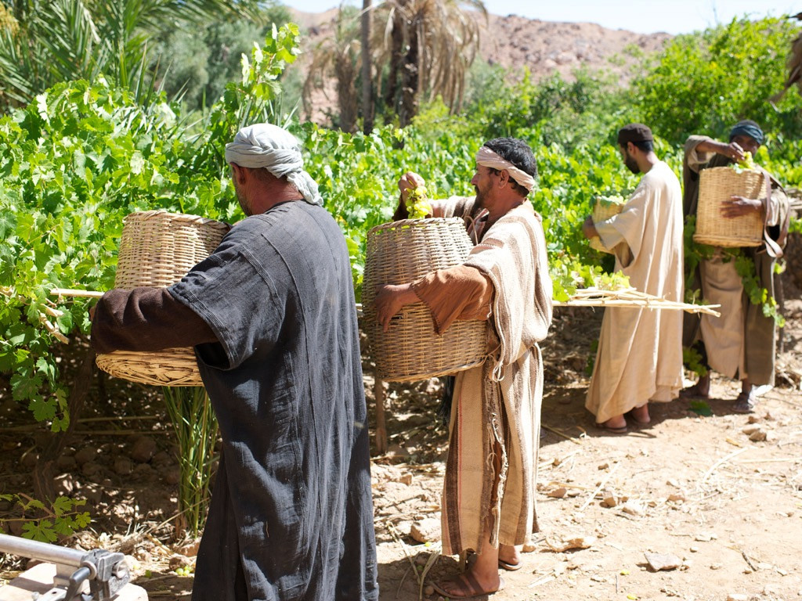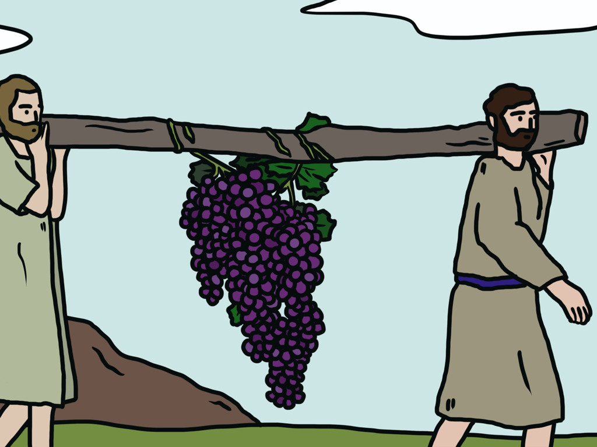

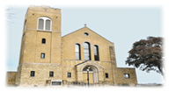
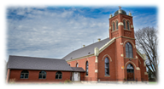


Holy Trinity Church (HT)
211 4th Street North
Goodhue, MN 55027
St Columbkill Church (SC)
211 4th Street North
Goodhue, MN 55027
St. Mary Church (SM)
221 Chester Avenue
Bellechester, MN 55027

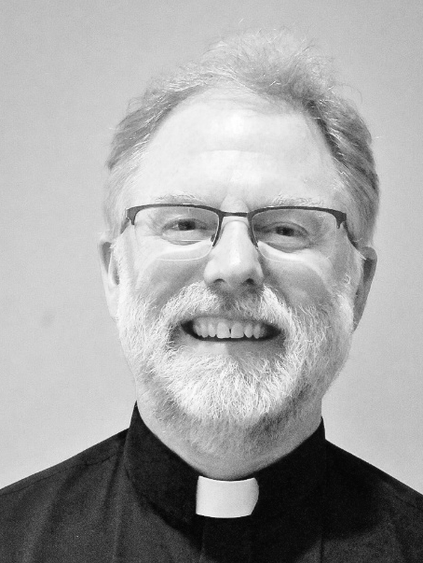
News/Events Office Hours, generally Mondays, 2:30 – 5:30pm

Holy Trinity is dedicated to protecting children and vulnerable adults. Volunteers serving with minors and vulnerable adults must complete requirements before engaging in ministry. Contact, Zach Siebenaler parish Safe Environment Coordinator, at: faithformation@holytrinitygoodhue.org.
This is God’s invitation: “Come to the royal wedding feast of my Son. You will honor me with your dignified presence, and I will honor you by giving you a feast for eternal life.” For God owns heaven and earth, and he can give it and his supernatural gifts to his faithful, that
they remain faithful.
We all know that a wedding ceremony and its following reception is a time of great joy and dignity. If we go, we want to dress in our Sunday best. We want to act with gracious support for the man and woman who have become one in the Sacrament of Holy Matrimony, for God is the author of human marriage.
To be invited by the King of the universe to his only Son’s wedding feast is of the greatest honor. If we understand this opportunity, we will dress our best and be the best we can be
for the royal groom and his bride, giving them our loyalty and a generous gift.
But who is the bride at this wedding feast? It is actually the Church, for this wedding feast is a celebration of God the Son becoming one with his bride the Church, thereby making the
Church and her faithful children, members of the royal family of God.
We read in the Gospel of John of how Jesus changed water into wine at the wedding at Cana, after his Mother, Mary, asked him to intervene. This was a sign that Jesus Christ raised the natural union of a man and woman to a supernatural union, a sacramental union, which is pleasing to God, for it is a covenant that reflects Christ’s love for his bride, the Church.
For this reason, baptized Catholics should be married in a Catholic Church, or at minimum be prepared for marriage by a Catholic priest or a deacon, and then receive permission by
their Catholic Bishop to be married in another Church.
Jesus Christ is the Messiah, the divine leader of his Catholic Church. He is God’s Son who unites himself to our soul and body through the Sacrament of Baptism, and strengthens and
completes this covenant of love and truth through the Sacrament of Confirmation and Holy Communion – the royal wedding feast.
Unfortunately, some of the Jews at the time of Jesus were not ready to accept God’s call to the fulness of his love and holiness. Many of them were too occupied with their farm, or their business, or tried to remove the servants of God by killing them spiritually or physically.
What happens to these people who ignore the invitation all their life and never repent? Jesus Christ is quite clear; the King of the universe punishes their rebellion by having them killed and their cities burnt down. This is what we read in today’s Gospel, and we need to attend to it carefully because life and salvation come as a free gift from God through Jesus Christ.
It is true that God is all merciful, that is why he invites us, the undeserving, to the wedding feast in the first place. However, when people do not convert and live virtuous lives, he protects those who do respond by applying his justice. God lovingly rewards the virtuous and those who strive for virtue, while he punishes the vicious, hoping they repent and allow him to make them holy through his Church, starting with baptism.
It happens again and again throughout history. Many people, the good and the bad, repent of their sins and come to the wedding feast, and entrust themselves to God’s plan, but then many decide to reject God’s call to holiness.
In other words, they show up at the wedding feast, but instead of taking the wedding garment that was handed out to them by the servants of God, they decide to dress in their own style, counting on their own works and sense of things. They want heavenly gifts, but in their human style, which is always imperfect. They do not want to convert to God’s true and noble plan.
What happens to the person who does not dress their body modestly, nor dress their soul with the virtues of faithful prayer, hopeful service and love of God’s people and Commandments? Well, the King asks them a question, “My friend, how is it that you came in here without a wedding garment?”
The spiritually uninformed do not know what to say, that they should say with sincere sorrow for their sins, “Lord, have mercy. Christ, have mercy. Lord, have mercy”. They do not want to be thrown out into the darkness to wail and grind their teeth forever, which moves us to reach out to them and invite them to Mass, adoration, bringing food to the food shelf and going to church with you for confession.
We understand this and that is why we are here at the wedding feast of God’s love for us, to feast on his Gospel words, and to feast on his very body, blood, soul and divinity in the Holy Eucharist when we are fully dressed and prepared to receive him in our soul. If all the world lived this way, there would be no more wars, no more homes, businesses, schools and churches burned to the ground.
Soon enough, Jesus Christ will return to take us to the heavenly banquet where there will be no more temptation, no more weakness and sin; only the peace and joy of knowing that God has invited us to his wedding banquet of divine love, eternal life and lasting truth, and we have responded: dressed in the divine gifts that Jesus won for us that unite us to him for the glory of God and the salvation of souls.

Peace in Christ, Fr. Thomas McCabe

World Mission Sunday:

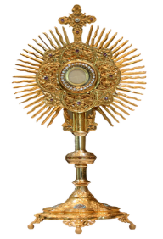
Behold the Lamb of God!
Adoration of the Blessed Sacrament: Mondays at St. Mary from 6:30-9:00PM, Wednesdays at Holy Trinity from 9:00AM-1:00PM, and Thursdays at St. Columbkill from 8:00AM-9:00AM (unless otherwise noted). Spend some time with Jesus!

Meals on Wheels: Desperately need of volunteers in the Goodhue & Bellechester area. Delivery routes require only a small commitment of time and often be completed during a lunch break. Contact Amber Merkens at amerkens@threerivercap.org or 507-403-3237
Pope Leo XIV’s Prayer Intention for October 2026:
Let us pray that the mental health ministry be established throughout the Church, helping to overcome the stigma and discrimination of persons with mental illness.
persons with ,mental illness.

OPEN HOUSE: Join in celebrating Rita Huneke’s 100th birthday. Sunday October 11th, 1 -4 pm at Goodhue Lions building. No gifts please.
Please pray for: Bob Eppen, Ann Merry, Ed Heppelmann, Ray & Gloria Poncelet, Dave Buck, Scott Cyert, Louise Heppelmann, Brent Hokanson, Anne Skalicky, Neil Stehr, Jen Berg, Marge Majerus, Shawn Frederixon, Gabe Ryan, Ryan Zorn, Beth Carlson, Chuck Havrilla, Randy Nardinger, Amy Feely, Alan Gadient, Wilma Seither, Susan Brown, Jocelyn O’Reilly, Marci Dillworth, George ZanMiller, Dave Huneke, Paul Huneke, Bryan Vogel, Steve O’Reilly, Paul Ryan, Loretta Froyum, Mary Haas, Bruce Nord, Rick Shane, Marlys Hofgren, Annette Gadient, Bishop Kevin Kenney, Berdell Gadient, Ellen Casey, Fr Kevin Zilverberg, Dave O’Reilly, Maya Keller, Greg and Mary Majerus, baby Rita Rose Ryan
From Father McCabe

St. Mary Church Cleaning: Scheduled for Sat. Oct 17, 7:00-11:30am, Fri. Oct 23, 9:00am – 3:pm and Sat. Oct 24, 7:00-11:30am. Supplies and a list of places to clean will on hand, as well as Adult Waiver forms to sign.

Marriage Encounter: Fall in love all over again by attending Oct 17-18 at Mt Olivet Retreat Center in Farmington. Register at: www.marriage.org. A “perfect marriage” is simply two imperfect people who refuse to give up on each other!

Calendar/Events
Sat. Oct 10 | HT | 4:45-5:20pm | Sacrament of Confession
Sun. Oct 11 | SM | 8:00am-8:20am | Sacrament of Confession
Mon. Oct 12 | SM | 6:30pm-9:00pm | Eucharistic Adoration
Tues. Oct 13
Wed. Oct 14 | HT | 9:00am-1:00pm | Eucharistic Adoration
Thurs. Oct 15 | SC | 8:15am-8:45am | Eucharistic Adoration & Sacrament of Confession
Fri. Oct 16
Sat. Oct 17 | HT | 4:45pm-5:20pm | Sacrament of Confession
Sun. Oct 18 | SM | 8:00am-8:20am | Sacrament of Confession
Men’s Retreat: October 23 – 24 at All Saints Church in Lakeville. Friday 5:30-9:30pm & Saturday 8:00am-5:00pm. Included all meals, 2 days of teaching, prayer, & fellowship prayer ministry & Eucharistic Adoration. Register at allsaintschurch.com/men

Save the Date! All Saint’s Day Celebration: Saturday, October 31st from 9:30-12:30pm at Holy Trinity. The 5th and 6th grade faith formation students will present the saint they have chosen as their role model from 10:00-11:15.
SUNDAY COLLECTION October 3/4, 2026
Holy Trinity | St. Columbkill | St. Mary
Church | Role | October 10/11 | October 17/18
HT: Sat. 5:30pm  Oct 10  Oct 17 | Musician | Wanda Schafer | Eileen Frischmon
HT: Sat. 5:30pm  Oct 10  Oct 17 | Cantor | Michelle Matthees | Katie Ludwig
HT: Sat. 5:30pm  Oct 10  Oct 17 | Lector | Judith Ramboldt | Maureen Lodermeier
HT: Sat. 5:30pm  Oct 10  Oct 17 | Servers | Aubriel, Oleana, Stuart O’Reilly
HT: Sat. 5:30pm  Oct 10  Oct 17 | Ushers | Mike Zorn | Mike Zorn
SM:Sun.  8:30am  Oct 11  Oct 18 | Musician | Wanda Schafer | Eileen Frischmon
SM:Sun.  8:30am  Oct 11  Oct 18 | Cantor | Laural Seither | Cathy O’Reilly
SM:Sun.  8:30am  Oct 11  Oct 18 | Lector | John Huneke | Brian Keller
SM:Sun.  8:30am  Oct 11  Oct 18 | Servers | Henry, Noah & Maya Keller | Isaac and Mabel Ryan
SM:Sun.  8:30am  Oct 11  Oct 18 | Ushers
SC: Sun. 10:00am Oct 11  Oct 18 | Musician | Cindy Eppen | Cindy Eppen
SC: Sun. 10:00am Oct 11  Oct 18 | Cantor | Shelly Jacobsen
SC: Sun. 10:00am Oct 11  Oct 18 | Lector | Barb Lexvold
SC: Sun. 10:00am Oct 11  Oct 18 | Servers | Jay Roschen, Madalyn, Caleb and Cameron Schofield | Alayna and Mazie Voth
SC: Sun. 10:00am Oct 11  Oct 18 | Ushers | Chris & JJ O’Reilly | Bruce and Blair McNamara
Activities include bake sale and lunch from 9:30 to 12:30, carnival from 10:00 to Noon. Bake sale items can be dropped off after 7:30 AM. Any proceeds benefit the Faith Formation Program. Contact Ann Buck at 651-764-3087 with questions.

English Country Dance Ball: St. Joseph Church, Miesville (23955 Nicolai Ave E) on Sat. Oct. 31. Jane Austen era music by Elite Rabble and dance caller Lisa Krahn. Social at 5:00 pm with dancing from 6 – 8:00pm. Period attire admired but not required.

Natural Family Planning: Classes on Church-approved methods to achieve or postpone pregnancy while embracing the beauty of God’s gift of sexuality.
Visit archspm.org/family or call 651-291-4551

