Holy Mass Schedule |  |  |  | Readings
Sat. | 5:30pm | HT | Oct 3 | +Patricia Dowden | See Mass Readings Below
Sun. | 8:30am | SM | Oct 4 | +Ron Bredemus | Is 5:1-7; Ops 80:9, 12-16, 19-20; Phil 4:6-9; Mt 21:33-43
Sun. | 10:00am | SC | Oct 4 | Parishioners | Is 5:1-7; Ops 80:9, 12-16, 19-20; Phil 4:6-9; Mt 21:33-43
Mon. | 8:00am | SM | Oct 5 | Kenny & Jane Lexvold Family | Gal. 1:6-12; Ps 111:1b-2, 7-9, 10c; Lk 10:25-37
Tues. | 8:00am | HT | Oct 6 | Names in Memorial Book | Gal 1:13-24; Ps 139:1b-3, 13-15; Lk 10:38-42
Wed. | 8:00am | HT | Oct 7 | +Patricia Dowden | Gal 2:1-2, 7-14; Ps 117:1bc-2; Lk 11:1-4
Thurs. | 9:00am | SC | Oct 8 | +Judy Ford | Gal 3:1-5 (Ps) Lk 1:69-75; Lk 11:5-13
Fri. |  |  | Oct 9 |  | Gal 3:7-14; Ps 111:1b-6; Lk 11:15-26
Sat. |  |  | Oct 10 |  | Gal 3:22-29; Ps 105:2-7; Lk 11:27-28
Sat. | 5:30pm | HT | Oct 10 | +Ron Bredemus | See Mass Readings Below
Sun. | 8:30am | SM | Oct 11 | Parishioners | Is 25:6-10a; Ps 123:1-6; Phil 4:12-14, 19-20; Mt 22:1-14 or 22:1-10
Sun. | 10:00am | SC | Oct 11 | Bill & Judy O’Reilly Family
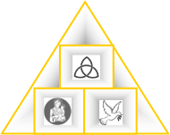
New Mass Times
St. Mary’s Sunday
Mass 8:30am

St. Columbkill
Sunday Mass
10:00am
Fr. Thomas McCabe, Pastor: pastor@holytrinitygoodhue.org
Zachary Siebenler, Faith Form. Assistant/Safe Environment Coordinator: faithformation@holytrinitygoodhue.org
Cathy O’Reilly, Administrative Assistant/Bulletin Editor/Bookkeeper: admin@holytrinitygoodhue.org

Twenty-seventh Sunday in Ordinary Time, Oct. 4, 2026
Holy Trinity Parish
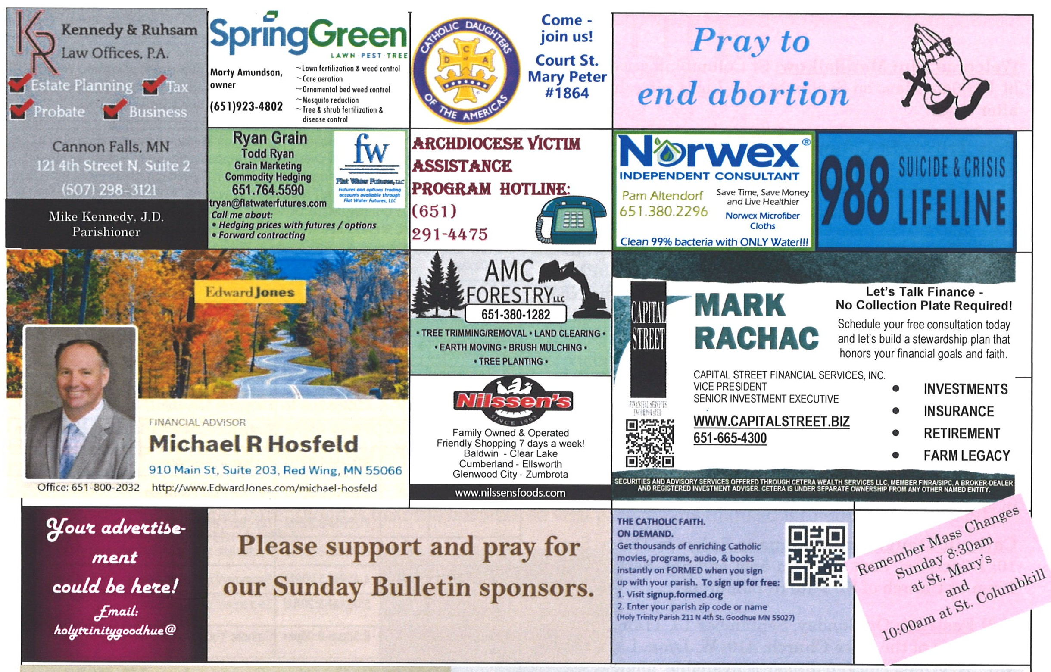
Welcome, Melanie Ann Adams to our family of faith here at Holy Trinity Parish. Melanie Ann is the daughter of Justin and Jennifer Adams. She was baptized on Sunday, September 13th after the 10:00 am Mass at St. Columbkill. Melanie’s older sister is Harper. Praise God for our growing family of faith!
Appalachia ChristMas Mission
Our 3 churches will again be helping with the mission sponsored by the Archdiocese Council of Catholic Women.
A semi-trailer donated by Terminal Transport in Roseville will deliver donated items to 4 parishes in Kentucky. The parish addresses are listed at the back of each church along with a list of suggested new gifts during the month of October. Please donate no later than October 25th. Any monetary donations can be included in the collection basket or sent directly to Holy Trinity Church, just note it is for the Appalachia Mission. Thank you for making someone’s Christmas merrier.

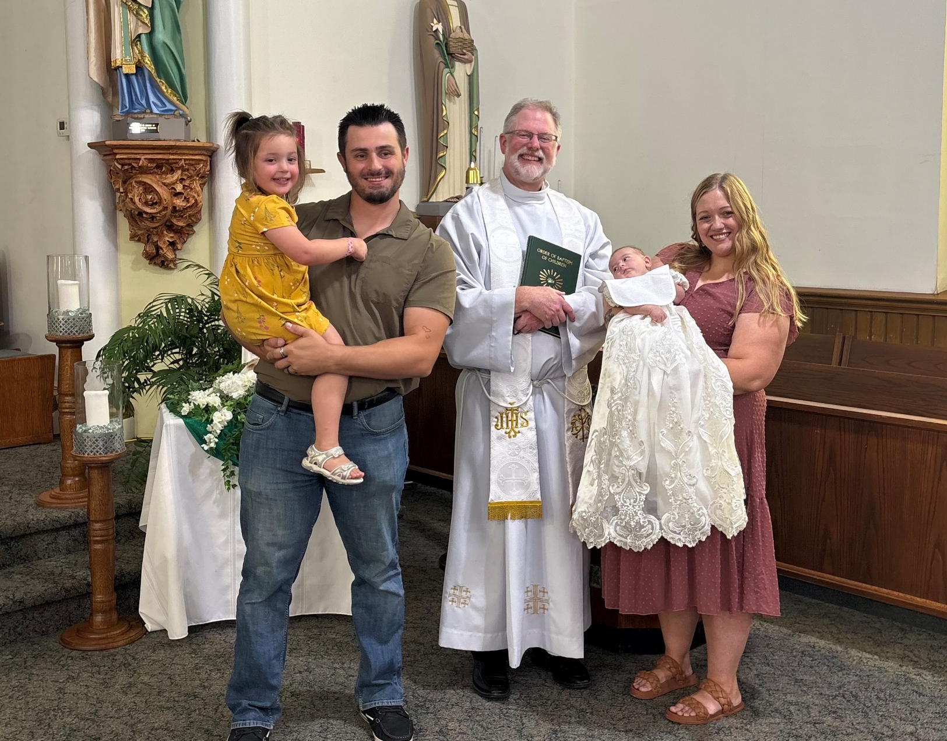

Note New Emails:
Fr, McCabe: pastor@holytrinitygoodhue.org
Zach Siebenaler: faithformation@holytrinitygoodhue.org
Cathy O’Reilly: admin@holytrinitygoodhue.org

Welcome to our Parish Church
Mission: We grow together in Christ.
Address: PO Box 275, Goodhue, MN 55027
Office/Emergency Phone: 651-923-4472
Email: admin@holytrinitygoodhue.org

Website: www.holytrinitygoodhue.org
Office Hours: Generally, Mondays 2:30-5:30pm, unless otherwise noted.

Building Use Request: Call the office
Confession: Sat. 4:45-5:20pm at Holy Trinity; Sun. 8:00-8:20am at St. Mary; Thurs. 8:00-8:45am at St. Columbkill
Baptism: Call at least 3 months before the birth to attend a class and set a tentative date.
First Penance/Eucharist: Register for 1st grade catechism classes in preparation.
Confirmation: Register as soon as possible in the fall since there are requirements including weekly Mass attendance.
Marriage: Please call Father McCabe at least one year prior to tentative date.
Anointing of the Sick: Contact the office especially if serious illness, near death or upcoming major surgery.
Pastoral Care of the Sick: If you move to a nursing home/care facility and would like a priest to visit or are unable to attend Mass and would like Communion at home, contact the office.
Funerals: Contact the office
Mass Intentions: Mail to office or place in collection. ($10/Mass suggested.) Only one name or one couple, and please indicate whether person is living or deceased.
Bulletin Items: Email to admin@holytrinitygoodhue.org by Tuesday noon. The parish office reserves the right to edit.
Trustees:
Samantha Dowden (secretary)
Ed McNamara (treasurer) 651-923-4777
Finance Chair:
Mike Zorn 651-258-4165
Pastoral Council Chair:
Jake Letsinger 763-486-7418

Jesus said to them, “Did you never read in the Scriptures: The stone that the builders rejected has become the cornerstone; by the Lord has this been done, and it is wonderful in our eyes?
Therefore, I say to you, the Kingdom of God will be taken away from you and given to a people that will produce its fruit.”
MT 21:42-43

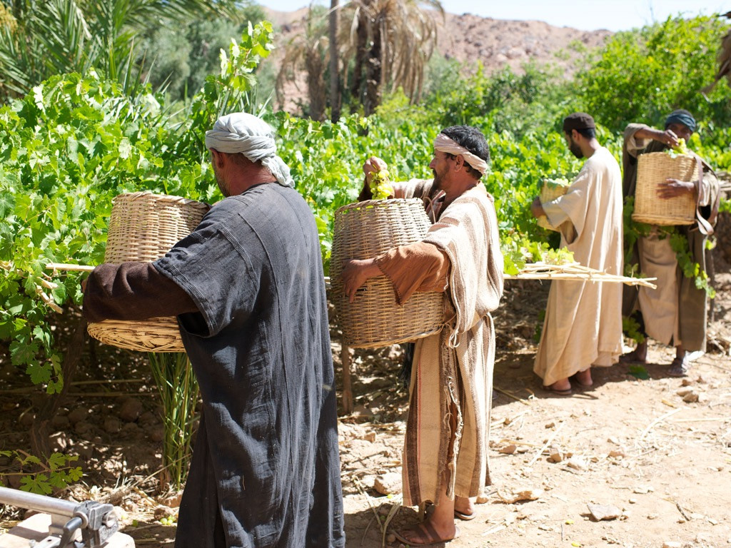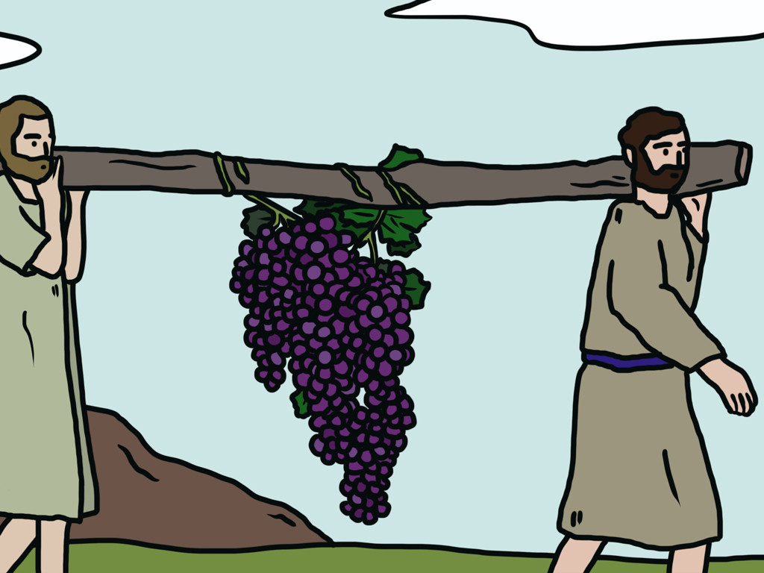

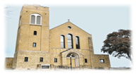
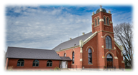
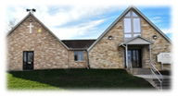

Holy Trinity Church (HT)
211 4th Street North
Goodhue, MN 55027
St Columbkill Church (SC)
211 4th Street North
Goodhue, MN 55027
St. Mary Church (SM)
221 Chester Avenue
Bellechester, MN 55027

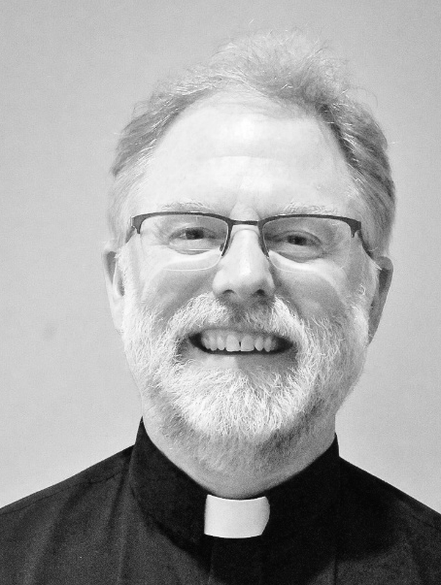
News/Events Office Hours, generally Mondays, 2:30 – 5:30pm

Holy Trinity is dedicated to protecting children and vulnerable adults. Volunteers serving with minors and vulnerable adults must complete requirements before engaging in ministry. Contact, Zach Siebenaler parish Safe Environment Coordinator, at: faithformation@holytrinitygoodhue.org.
Do I own my life? Do I take responsibility for the things I say, do and think? Have I been a good steward of my life?
As I look at my family photo albums, I see myself among my brothers and sisters during Christmas time, birthdays, celebrations of Baptisms, Confirmations, the other Sacraments, and graduations.
As I think about the experiences I had in these photos, I realize that my life is my own. I worked for the rewards I received and decided to participate in the events around me. I have taken responsibility for my life, but it was only because God gave me my life through my family, and in a way sustains my life through my country.
My family helped me to understand that my life, and every human life, is a gift from God. We have a right to life, which is an unalienable right that comes from God. This truth has been enshrined in our Country’s Declaration of Independence.
But we also have the responsibility to live that life guided by reason, and reason guides us to protect all innocent human life. We are called to be good stewards and protect human life, that supreme natural gift from God. As Catholic Christians, we are called to be good stewards in the protection and participation of the supernatural life of God’s saving grace found in the Sacraments.
Since God is the giver and sustainer of our human life through family and country, then I have a responsibility to be a good steward by loving and serving God, family and country. Whenever I look at my family photo albums or think about these things, my love grows for God, family and country, for we truly belong.
On one page there is a photo of me as a baby, and a card with a rose on it which was given to my mom by my dad at my birth. My dad would give a rose and a card to my mom after each birth of my six other siblings as a sign of his love and devotion to her. It was a reminder of the promise he made to her on their wedding day that he would be there to provide and protect her and their children.
It was not always easy. My parents rented several apartments before they could afford their own home. My dad did not always like working overtime as a security guard, nor did my mom always like having the late shift as a nurse. However, they knew that these sacrifices were essential to keep the family growing physically and spiritually.
Both my parents were good stewards by using their gifts to build up the family of faith, since they both taught religious education together. There, my classmates and I began to understand that God is the giver of all good gifts, natural and supernatural. There, we learned that the Seven Sacraments are essential gifts of grace that are needed to be assured of our salvation.
Jesus Christ promises to be present in each Sacrament, beginning with baptism, and that is his divine gift to us. But we need to be good stewards and receive these divine gifts with humble and grateful hearts. We have the responsibility to live these Sacraments for the glory of God, which is our gift back to God and his Church.
One way to prepare for the reception of the Sacraments is to practice using the Church’s sacramentals. Sacramentals help dispose our souls for the reception of the Sacraments and can be an occasion of grace to grow in our faith, hope and love.
During the month of October the Church focuses on the Rosary as a powerful sacramental. For we review the key moments in our family of faith. By meditating on the life of St. Mary and her divine Son, Jesus, we grow in our love and service of God.
In fact, the Rosary is so important that God attached promises to its prayerful recitation. The Virgin Mary gave the rosary to St. Dominic, the founder of the Dominican religious community. Here are several of the 15 promises.
One: “Whoever shall faithfully serve me by the recitation of the Rosary shall receive signal graces.” These graces are signs to us of how God guides and protects us.
Two: “I promise my special protection and the greatest graces to all those who shall recite the Rosary.”
Three: “Whoever shall have a true devotion to the Rosary shall not die without the sacraments of the Church.”
And another one of my favorites out of the 15 promises given to us by the Mother of God: “The faithful children of the Rosary shall merit a high degree of glory in heaven.”
My friends in Christ, think of the recitation of the Rosary as a walk through a family of faith photo album. You can meditate on the words of the prayers, or see the mysteries played out in your imagination, or think of a person who may be living a mystery in their life – like a couple who will soon offer their child up to God through the mystery of baptism, similar to St. Joseph and St. Mary bringing their Child Jesus to the Temple.
My dad gave a rose to my mom for every child she gave birth to as a sign of his love and devotion to her. Every day we pray the Rosary we are crowning Mary with a bouquet of roses as a sign of our love and devotion to her and her divine Son, Jesus. When we do this, we are good stewards who produce the spiritual fruit of blessing ourselves, our family, our country and the Church we belong to. Peace in Christ, Fr. Thomas McCabe

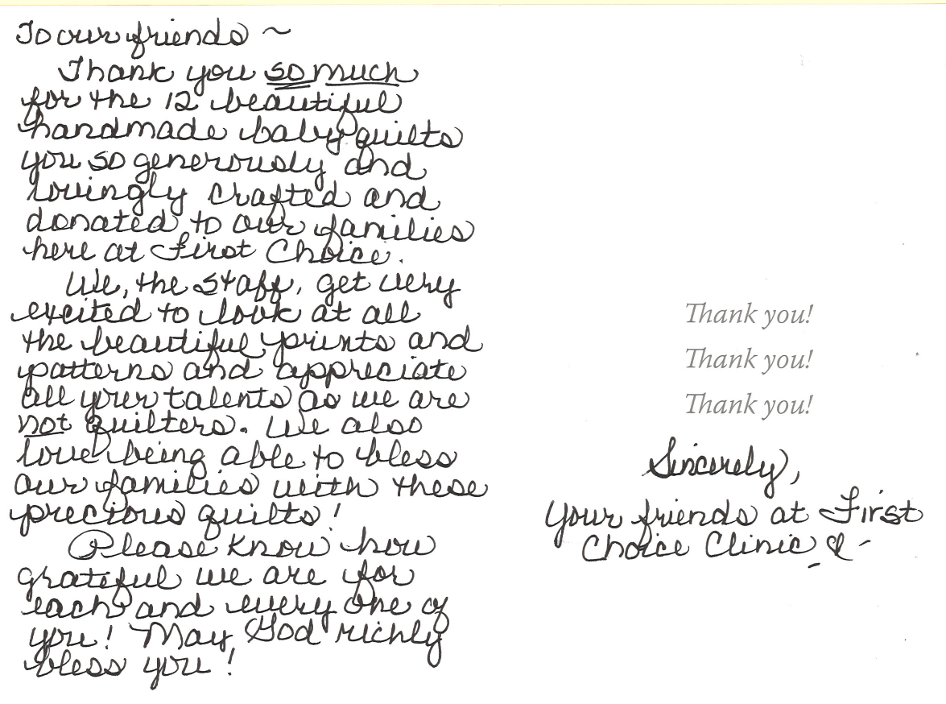

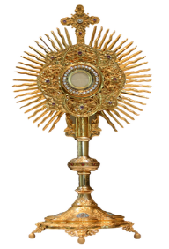
Behold the Lamb of God!
Adoration of the Blessed Sacrament: Mondays at St. Mary from 6:30-9:00PM, Wednesdays at Holy Trinity from 9:00AM-1:00PM, and Thursdays at St. Columbkill from 8:00AM-9:00AM (unless otherwise noted). Spend some time with Jesus!

Pope Leo XIV’s Prayer Intention for October 2026:
Let us pray that the mental health ministry be established throughout the Church, helping to overcome the stigma and discrimination of persons with mental illness.
persons with ,mental illness.
Calendar/Events
Sat. Oct 3 | HT | 4:45-5:20pm | Sacrament of Confession
Sun. Oct 4 | SM | 8:00am-8:20am | Sacrament of Confession
Sun. Oct 4 | SC | 11:00am | Deacon Mick Retirement Reception
Mon. Oct 5 | SM | 6:30pm-9:00pm | Eucharistic Adoration
Tues. Oct 6
Wed. Oct 7 | HT | 9:00am-1:00pm | Eucharistic Adoration
Wed. Oct 7 | HT | 2:20pm-3:30pm | 1st – 6th Faith Formation
Wed. Oct 7 | HT | 7:25pm-8:35pm | 7th – 9th Faith Formation
Thurs. Oct 8 | SC | 8:00am-8:45am | Eucharistic Adoration & Sacrament of Confession
Fri. Oct 9
Sat. Oct 10 | HT | 4:45pm-5:20pm | Sacrament of Confession
Sun. Oct 11 | SM | 8:00am-8:20am | Sacrament of Confession
Adore Him-He is Here: A two-hour documentary/drama at Marcus Theatre, 4340 Main Ave. SE Rochester. Only Sun. October 4 –Thurs. October 8. Fathom Entertainment brought to audiences The Blind in November 2023 and The Chosen, Last Supper; Part 1 in November 2025.

Life Banquet: Pro-Life Action Ministries is sponsoring a Banquet with speaker Dr. George Delgado on Oct. 5, 6:30-9:00pm at Heritage Center in Brooklyn Center, 6155 Earle Brown Drive. Tickets are available at plam.org/life-banquet.
Church | Role | October 3 / 4 | October 10/11
HT: Sat. 5:30pm  Oct. 3 & Oct 10 | Musician | Eileen Frischmon | Wanda Schafer
HT: Sat. 5:30pm  Oct. 3 & Oct 10 | Cantor | Laural Seither | Michelle Matthees
HT: Sat. 5:30pm  Oct. 3 & Oct 10 | Lector | Maria Halverson | Judith Ramboldt
HT: Sat. 5:30pm  Oct. 3 & Oct 10 | Servers | Nora, Brynn & Lucas Fredericks
HT: Sat. 5:30pm  Oct. 3 & Oct 10 | Ushers | Mike Zorn | Mike Zorn
SM: Sun.  8:30am  Oct 4 & Oct 11 | Musician | Wanda Schafer | Wanda Schafer
SM: Sun.  8:30am  Oct 4 & Oct 11 | Cantor | Taylor Dowden
SM: Sun.  8:30am  Oct 4 & Oct 11 | Lector | Pat Mensinnk | John Huneke
SM: Sun.  8:30am  Oct 4 & Oct 11 | Servers | Will Poncelet, Dereck Stehr | Henry, Noah & Maya Keller
SM: Sun.  8:30am  Oct 4 & Oct 11 | Ushers
SC: Sun. 10:00am Oct 4 & Oct 11 | Musician | Cindy Eppen | Cindy Eppen
SC: Sun. 10:00am Oct 4 & Oct 11 | Cantor | Denise Voth | Shelly Jacobsen
SC: Sun. 10:00am Oct 4 & Oct 11 | Lector | Michael Poncelet | Barb Lexvold
SC: Sun. 10:00am Oct 4 & Oct 11 | Servers | Brady and Liahna McNamara
SC: Sun. 10:00am Oct 4 & Oct 11 | Ushers | Bruce & Blair McNamara | Chris & JJ O’Reilly

First Choice Luncheon: Fundraising luncheon celebrating 20 years, Thurs. October 8th. Doors open at 11:30, lunch begins at noon. St Joseph Catholic Church, Red Wing. Call 651-267-4357 or email info@firstchoiceclinic.org

Dueling Pianos: Thursday, Oct. 8th 5:30pm reception, 6:30pm concert. Presented by First Choice Clinic at New River Assembly of God, 240 Spates Ave, Red Wing. Tickets $25.
Please pray for: Bob Eppen, Ann Merry, Ed Heppelmann, Ray & Gloria Poncelet, Dave Buck, Scott Cyert, Louise Heppelmann, Brent Hokanson, Anne Skalicky, Neil Stehr, Jen Berg, Marge Majerus, Shawn Frederixon, Gabe Ryan, Ryan Zorn, Beth Carlson, Chuck Havrilla, Randy Nardinger, Amy Feely, Alan Gadient, Wilma Seither, Susan Brown, Jocelyn O’Reilly, Marci Dillworth, George ZanMiller, Dave Huneke, Paul Huneke, Bryan Vogel, Steve O’Reilly, Paul Ryan, Loretta Froyum, Mary Haas, Bruce Nord, Rick Shane, Marlys Hofgren, Annette Gadient, Bishop Kevin Kenney, Berdell Gadient, Ellen Casey, Fr Kevin Zilverberg, Dave O’Reilly, Maya Keller
OPEN HOUSE: Join in celebrating Rita Huneke’s 100th birthday. Sunday October 11th, 1 -4 pm at Goodhue Lions building. No gifts please.
From Father McCabe
News/Events Office Hours, generally Mondays, 2:30-5:30pm

Marriage Encounter: Fall in love all over again by attending Oct 17-18 at Mt Olivet Retreat Center in Farmington. Register at: www.marriage.org. A “perfect marriage” is simply two imperfect people who refuse to give up on each other!

SUNDAY COLLECTION September 27, 2026
Holy Trinity | St. Columbkill | St. Mary
$356.00 | $935.00 | $1,211.00
Men’s Retreat: October 23 – 24 at All Saints Church in Lakeville. Friday 5:30-9:30pm & Saturday 8:00am-5:00pm. Included all meals, 2 days of teaching, prayer, & fellowship prayer ministry & Eucharistic Adoration. Register at allsaintschurch.com/men

Save the Date! All Saint’s Day Celebration: Saturday, October 31st from 9:30-12:30pm at Holy Trinity. The 5th and 6th grade faith formation students will present the saint they have chosen as their role model from 10:00-11:15.
Activities include bake sale and lunch from 9:30 to 12:30, carnival from 10:00 to Noon. Bake sale items can be dropped off after 7:30 AM. Any proceeds benefit the Faith Formation Program. Contact Ann Buck at 651-764-3087 with questions.

English Country Dance Ball: St. Joseph Church, Miesville (23955 Nicolai Ave E) on Sat. Oct. 31. Jane Austen era music by Elite Rabble and dance caller Lisa Krahn. Social at 5:00pm with dancing from 6 – 8:00pm. Period attire admired but not required.

